Lab 3

Abstract

This lab is an exercise in building a circuit that performs ordinary AM modulation, demodulates it, and analyzes the effect of noise on the output of the circuit. To test this, an adder circuit is created were the inputs are a simple sine wave and a noise generator. Then, the resulting signal is passed through a low-pass signal to create a base-band system. The filtered signal is then passed through an envelope detector, which acts as a coherent demodulator. The resulting signal would then represent the modulation signal.

Materials

* Function generator
* Oscilloscope
* Breadboard
* Circuitry: LM411 op-amp, resistors, capacitors, diode

Procedure

1. Construct the adder. Connect two 10kΩ resistors to the negative terminal of the op-amp. Then connect the a 10kΩ resistor from the output to the negative terminal for negative feedback. Positive terminal goes to ground.
2. Set up one function generator to produce an AM signal where the carrier is at 630kHz and the message is at 5kHz.

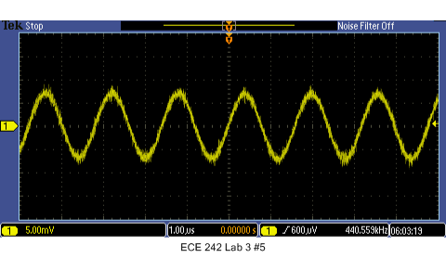

1. Set up the other function generator to output a noise signal with a peak-to-peak amplitude of 50mV.

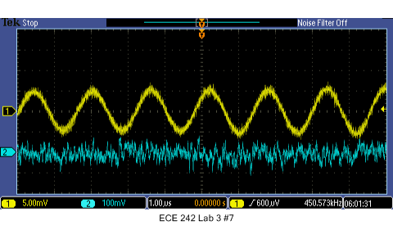

1. Connect both signals to the inputs of the adder and view the magnitude spectrum of the output on the oscilloscope using the FFT function.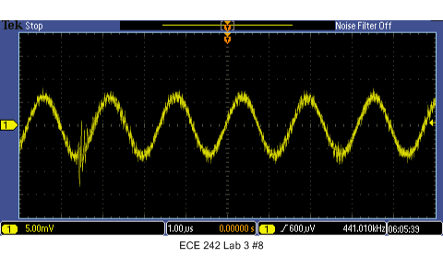
2. Observe the effect of increasing noise on the magnitude spectrum.
   1. What effect does the of the noise has on the spectrum of the modulated signal?  
        
      As the amplitude of the noise was increased, the frequencies present that were not of the AM signal increased in magnitude as well, rather equally across the spectrum. This shows that the frequency content of noise is spread out across all frequencies. The magnitudes of the carrier and the message slightly dropped in amplitude as the noise increased. This might be due to FFT attributing more content to other frequencies as the AM signal becomes noisier.
   2. What happens when you increase and decrease the modulation?